**Excel Assignment - 7**

Que.1) Using Insert Function, give examples of any function available in the different dropdowns present in the function library. For example AutoSum, Recently Used, Text, Date & Time, etc.

Ans. - To insert SUM function, need to follow the following steps:

Step 1. Select a cell.

Step 2. Click the Insert Function button. The ‘Insert Function‘ dialog box appears.

Step 3. Look for a function or select a function from a category. For example, choose SUM from the statistical category.

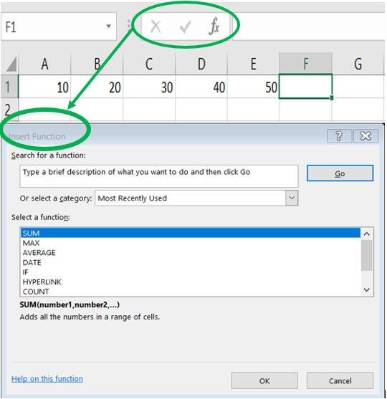

Step 4. Click OK. The ‘Function Arguments‘ dialog box appears.

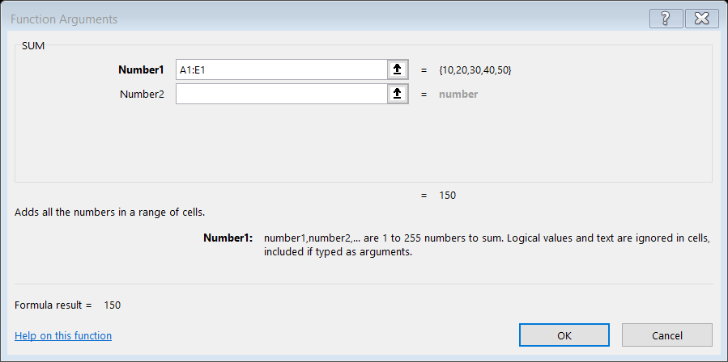

Step 5. Click within the Range box and select the range A1:E1.

Step 6. Click OK. Excel will sum all the number which are present from A1:E1.

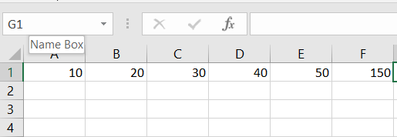

To insert MAX function, need to follow the following steps: Step 1. Select a cell.

Step 2. Click the Insert Function button. The ‘Insert Function‘ dialog box appears.

Step 3. Look for a function or select a function from a category. For example, choose MAX from the statistical category.

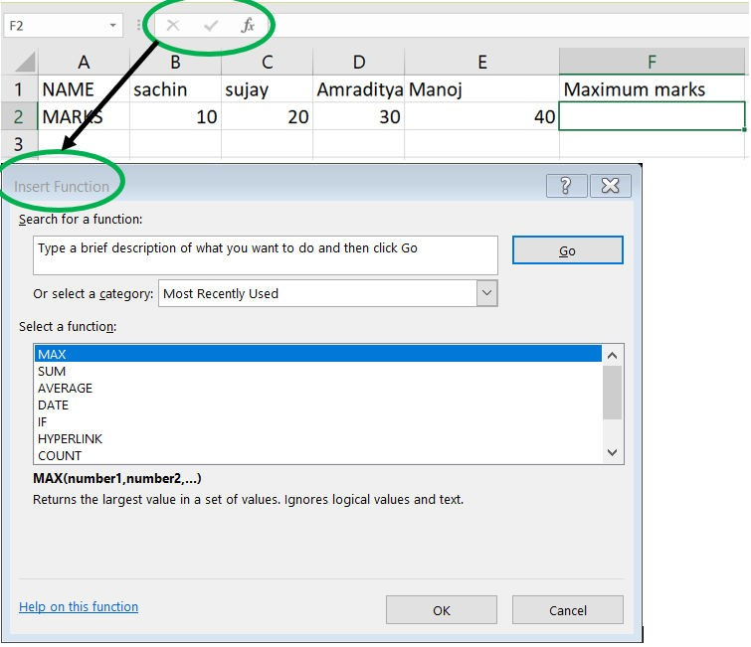

Step 4. Click OK. The ‘Function Arguments‘ dialog box appears.

Step 5. Click within the Range box and select the range A1:E1.

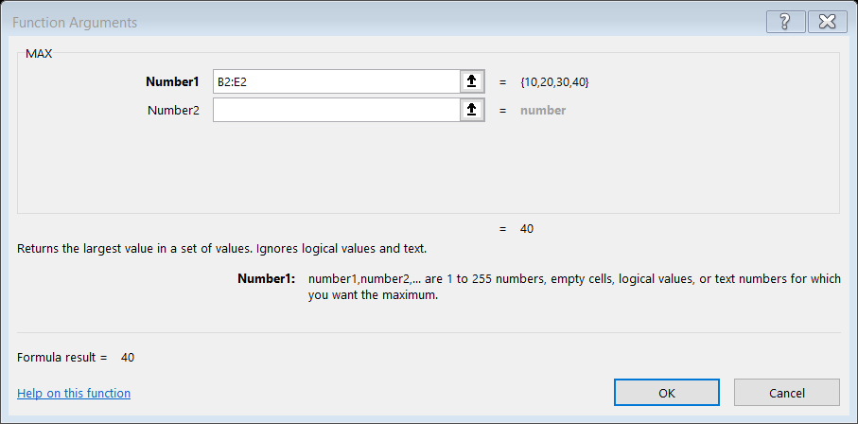

Step 6. Click OK. Excel will MAX all the number which are present from B2:E21

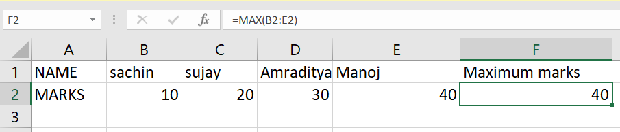

To insert COUNT function, need to follow the following steps: Step 1. Select a cell.

Step 2. Click the Insert Function button. The ‘Insert Function‘ dialog box appears.

Step 3. Look for a function or select a function from a category. For example, choose COUNT from the statistical category.



Step 4. Click OK.

The ‘Function Arguments‘ dialog box appears.

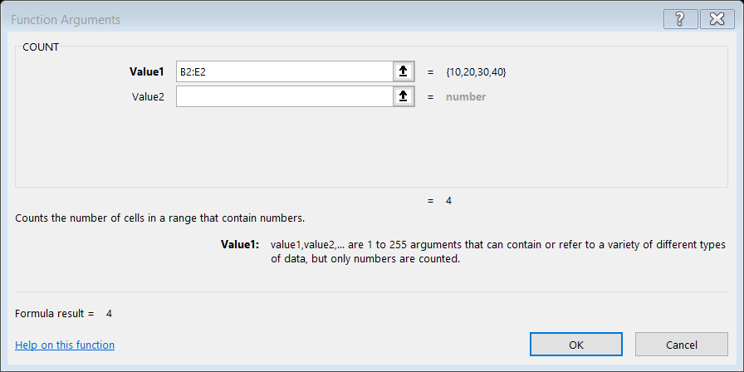

Step 5. Click within the Range box and select the range B2:E2.

Step 6. Click OK. Excel will COUNT all the number which are present from B2:E2

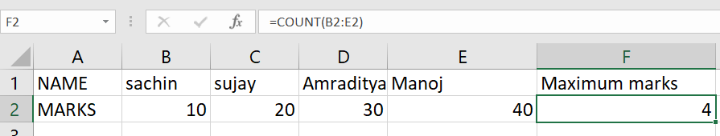

Que.2) What are the different ways you can select columns and rows?

Ans. - Different ways to select one or more rows and columns:

* 1. Select the letter at the top to select the entire column or click on any cell in the column and then press Ctrl + Space.
  2. Select the row number to select the entire row or click on any cell in the row and then press Shift + Space.

Que.3) What is AutoFit and why do we use it?

Ans. – Auto Fit is used to change the column width to automatically fit the contents. It is used to show contents of column without hiding any part of it. The steps for using AutoFit:

i) Select the column or columns that you want to change.

ii) On the Home tab, in the Cells group, click Format.

iii) On the Home tab, click Format

iv) Under Cell Size, click AutoFit Column Width.

Note: To quickly autofit all columns on the worksheet, click the Select All button, and then double-click any boundary between two column headings.

Que.4) How can you insert new rows and columns into the existing table?

Ans. –

1. Different ways to add a new row or column to an existing table:
   1. Use Insert to add a row:
      1. To insert a row, pick a cell or row that's not the header row, and right-click. To insert a column, pick any cell in the table and right-click.
      2. Point to Insert, and pick Table Rows Above to insert a new row, or Table Columns to the Left to insert a new column.
   2. By pasting data:
      1. To add a column, paste data to the leftmost cell below the last row of table.
      2. To add a column, paste data to right of the table’s rightmost column.
   3. By typing text
      1. Start typing text below the last row.
      2. Start typing text to the right of the rightmost column of table.
   4. Using resize table:
      1. Click anywhere in the table, and the Table Tools option appears.
      2. Click Design > Resize Table.

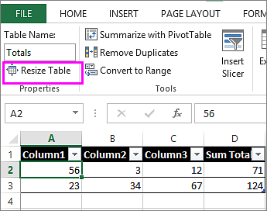

* + 1. Select the entire range of cells you want your table to include, starting with the upper-leftmost cell.

Que.5) How do you hide and unhide columns in excel?

Ans. – Right click an column and select hide to hide it.

Right click the adjacent columns of an hidden column, then select unhide to show it.

Que.6) How do you hide and unhide columns in excel?

Ans. –

